ALL-OPTICAL 3D PHOTOACOUSTIC SCANNER FOR CLINICAL VASCULAR IMAGING

N.T. Huynh*^{1,2}, E. Zhang*^{1,2}, O. Francies⁵, F. Kuklis⁷, T. Allen¹, J. Zhu¹, O. Abeyakoon⁴, F. Lucka⁶, M. Betcke³, J. Jaros⁷, S. Arridge³, B. Cox¹, A. Plumb⁴, P. Beard^{1,2}

¹Department of Medical Physics and Biomedical Engineering, University College London, UK
²Wellcome/EPSRC Centre for Interventional and Surgical Sciences, University College London, UK
³Department of Computer Science, University College London, UK
⁴University College London Hospital NHS Foundation Trust, UK
⁵Imperial College Healthcare NHS Trust, UK
⁶Centrum Wiskunde & Informatica, Amsterdam, The Netherlands
⁷ Faculty of Information Technology, Brno University of Technology, Czech Republic

*These authors contributed equally to the work.

Abstract

Widefield photoacoustic tomography (PAT) offers new opportunities for the clinical assessment of cancer, diabetes and other diseases characterised by changes in superficial microvascular anatomy and function. PAT imaging to sub-cm depths for the assessment of microcirculatory abnormalities in the skin or subcutaneous tissues is however challenging. This is due to the need for fine spatial-temporal sampling of the incident photoacoustic wavefield which is difficult to achieve with piezoelectric receivers used in conventional PAT scanners. PAT scanners based on the Fabry Perot polymer film ultrasound sensor can meet this need, but suffer from excessively long scan times, of the order of several minutes which precludes clinical use. This has now been overcome by parallelising the sensor read-out scheme, the use of high PRF excitation lasers and compressed sensing. An A-line rate acceleration of up to 3 orders of magnitude has been achieved, enabling high resolution 3D image data sets to be acquired in several seconds; in some cases a few hundred ms, permitting dynamic 3D imaging. A practical, mobile scanner has been developed and evaluated via human imaging studies. It has been shown that it can provide detailed in vivo images of microvascular anatomy in the skin and subcutaneous tissues to depths approaching 15 mm with a resolution in the 50-150µm range. To illustrate clinical applicability, the scanner has been evaluated by imaging patients and visualising microvascular abnormalities associated with peripheral vascular disease, skin inflammation and rheumatoid arthritis. These developments advance the clinical translation of short-range high resolution PAT as a generic new imaging tool for the assessment of diseases characterised by superficial vascular changes.

INTRODUCTION (1233)

Visualising superficial microvascular anatomy to sub-cm depths is relevant to the clinical assessment of a wide range of vascular pathologies including those associated with skin cancers, dermatological conditions¹, the diabetic foot, peripheral vascular disease and inflammatory diseases such as arthritis. A plethora of imaging modalities have been investigated for this purpose. Optical imaging techniques, can provide high vascular contrast and functional information via the spectroscopic measurement of blood oxygenation. However, strong photon scattering in the skin and subcutaneous tissues presents a challenge. It limits the penetration depth to less than 1 mm with microscopy, OCT and other methods that rely on predominantly un-scattered ballistic photons. Greater penetration depth is achievable using techniques such as laser Doppler perfusion and speckle contrast imaging which exploit diffuse light or semi-ballistic photons. However, with these methods, scattering limits the spatial resolution to the mm-cm scale precluding the visualisation of microvascular architectures at the level of individual vessels. Conventional non-contrast clinical Doppler ultrasound imaging provides limited microvascular contrast with emerging ultrafast methods, offering higher sensitivity. However, both rely on the detection of moving blood limiting their sensitivity to slow or static blood flow and precluding the measurement of blood oxygenation.
Photoacoustic imaging provides an alternative approach based on the optical generation of ultrasound waves in tissues,,,. In its most common implementation, the so-called widefield photoacoustic tomography (PAT) mode⁹, a large area pulsed laser beam flood-illuminates the tissue. Optical absorption by pigmented molecules such as haemoglobin results in impulsive heating and the subsequent generation of broadband ultrasound waves. By detecting these waves at the tissue surface using an array of omnidirectional ultrasound receivers, an image of the internal tissue structure based on its optical absorption distribution can be reconstructed. Since acoustic waves are scattered much less than photons in soft tissues, PAT avoids the range-resolution limitations that afflict optical methods: depths of a few centimetres with depth-dependent spatial resolution ranging from tens to hundreds of micrometres are readily achievable. Moreover, because contrast is defined by optical absorption, PAT vascular images are based on the direct detection of strongly absorbing haemoglobin rather than the indirect detection of blood flow that US relies upon. This offers the prospect of visualising small vessels otherwise invisible under ultrasound, the detection of slow or static blood and the spectroscopic measurement of blood oxygenation with the further prospect of blood flow measurement,,. These attributes have led to suggestions that PAT could find application as a tool for the clinical assessment of microvascular changes associated with cancer,, cardiovascular disease, diabetes, inflammatory conditions in the skin and joints,, and soft tissue damage,.
Despite its promise, the practical implementation of PAT poses several non-trivial instrumentation related challenges, particularly when imaging superficial anatomy to sub-cm depths. For such shallow depths, frequency-dependent acoustic attenuation is modest. This means the photoacoustic frequency content can extend to several tens of MHz. Accurately recording the spatial-temporal characteristics of the photoacoustic wavefield thus demands an ultrasound detection system with a commensurately broad detection bandwidth, fine spatial sampling on a tens of micron scale to satisfy spatial Nyquist and sub-100µm element sizes for low directional sensitivity. A transparent detector is also desirable to permit delivery of the excitation laser beam through the detector, the so-called backward mode operation. Meeting these requirements is challenging using traditional piezoelectric ultrasound detectors which are most commonly used in PAT scanners. They tend to be insufficiently broad-banded, their detection sensitivity scales with element size becoming vanishingly small for sub-100µm dimensions and most are opaque. Moreover, for clinically acceptable 3D image frame rates, a 2D detector array composed of several thousand micron-scale elements is required presenting an overwhelming challenge in terms of technical complexity and cost. The scalability of CMUTs holds future promise in this respect but only relatively small-channel count arrays have been used in PAT systems to date. Acoustic-resolution photoacoustic microscopy (AR-PAM), can address some of these challenges by using a mechanically scanned large-area focused piezoelectric transducer to record the photoacoustic signals. However, unlike PAT, it is not readily parallelisable resulting in long acquisition times, typically in excess of 1 minute and the fixed focal depth of the transducer limits penetration depth range.
Ultrasound detectors based on optically resonant structures have the potential to overcome the above limitations on account of their widebandwidth, small element size, high sensitivity and optical transparency,,,,,,,. However, few have made the transition from the laboratory to practical in vivo PAT imaging tool. One that has is the Fabry Perot polymer film ultrasound sensor. It has found application as the detector within a high resolution preclinical small animal PAT scanner. It has been shown that this instrument can provide highly detailed in vivo 3D vascular images,, to sub-cm depths. However, its adaption for clinical use has been hindered by low A-line rates of 10-50 A-lines/s resulting in long scan-times, typically several minutes. This is a consequence of the single-beam sequential read-out scheme used to map the FP sensor output, the low excitation laser PRFs used and the large number of detection points (~20,000) required to reconstruct a high quality 3D PAT image. An early multi-beam scanner which provided modest parallelisation of the sensor read-out yielded faster acquisition but the scan time was still 1.5 minutes for similar imaging parameters. Although acceptable for imaging an anaesthetised mouse or research studies on humans under carefully controlled conditions where a high degree of immobility is achievable, such long acquisition times are incompatible with routine clinical use.
The current work addresses these limitations by demonstrating a practical FP based clinical scanner that provides up to three orders of magnitude faster acquisition. With A-line rates up to 64,000 lines/s achieved through a combination of a parallelised multi-beam readout scheme, the use of high PRF excitation lasers and compressed sensing, scan-times of a few seconds or even a few hundred ms have been realised. Moreover, they have been achieved without compromising the excellent 3D image quality of earlier-generation FP sensor based PAT scanners. We show for the first time that these significant reductions in scan-time permit the acquisition of 3D in vivo images of unprecedented quality and enables dynamic real-time 3D and video rate 2D imaging in humans. To illustrate clinical applicability, we further show how the scanner can be used to visualise disease-specific vascular changes in patients with peripheral vascular disease, skin inflammation and rheumatoid arthritis. This study advances the development of the technology as a generic new imaging tool for the clinical assessment of a diseases characterised by superficial microvascular abnormalities.

RESULTS

Fabry Perot planar PAT scanner: system overview
Images were acquired using the custom-built instrument depicted in Figure 1. The system comprises a pulsed excitation laser for generating the photoacoustic waves and a Fabry-Perot (FP) ultrasound scanner for mapping them over the surface of the skin. Fig 1(a) illustrates its working principles. The photoacoustic excitation laser light emerges from an optical fibre resulting in a large diameter (>20mm) beam incident on the Fabry Perot ultrasound sensor (FPUS) head - the excitation laser wavelength is typically chosen to lie in the 700-900nm spectral range for deep tissue penetration. The FPUS head (see Methods) comprises a 1.5 cm thick wedged PMMA substrate overlaid with a thin polymer spacer sandwiched between a pair of dichroic mirrors that acts as a Fabry Perot interferometer (FPI). Since the mirrors are optically transparent in the 560nm - 1300nm spectral range (Suppl. Figure 1), the excitation beam passes through the sensor and flood-illuminates the underlying tissue. Broadband ultrasound waves are subsequently generated via the photoacoustic effect and propagate to the sensor head where they modulate the optical thickness of the FPI and thus its reflectivity distribution. The latter is then read-out by sequentially scanning an array of up to 64 focused laser beams over the surface of the sensor step-by-step, one step per excitation laser pulse. By recording the time-varying reflected optical power modulation at each point of the scan, the spatial-temporal distribution of the incident photoacoustic wavefield can thus be mapped in 2D. From this data, a 3D image of the initial pressure distribution is reconstructed using an acoustic backpropagation algorithm. As depicted in Figure 1b, the instrument is configured as a mobile cart-based platform with an imaging head on an articulated arm to facilitate positioning on different parts of the body for in vivo human imaging studies.

Scan parameters, bandwidth, spatial resolution and NEP
The maximum rectangular scan area that the scanner can provide is 21 x 19.4 mm². For the step sizes of dx=dy=108µm and dx=dy=54µm used in this study, this enables the synthesis of arrays of 34,560 and 138,240 detection points respectively. Dense spatial sampling on this scale is a pre-requisite for short-range high resolution PAT and achievable with the FP sensor by virtue of its optical-diffraction limited read-out scheme but unattainable with current conventional ultrasound detection technology. A broadband acoustic frequency response is also required to capture the frequency content of the photoacoustic wavefield. This requirement is also challenging to meet using conventional ultrasound receivers but achievable with the FP sensor due to the well matched acoustic properties of the polymeric materials used in its construction. As shown in figure 1(c), the FP sensor provides a well behaved frequency response between 50kHz and 35MHz (-3dB) that is more than sufficient to capture the broadband frequency content of photoacoustic signals generated in tissue. The fine spatial sampling and widebandwidth of the system yields near acoustic-diffraction limited spatial resolution. At the centre of the scan area, the lateral resolution (see methods) varies from 60µm to approximately 120µm over the depth range 1mm to 12mm (Figure 1d). The measured vertical resolution depends largely on the sensor bandwidth was found to be spatially invariant at 45µm over the FOV.

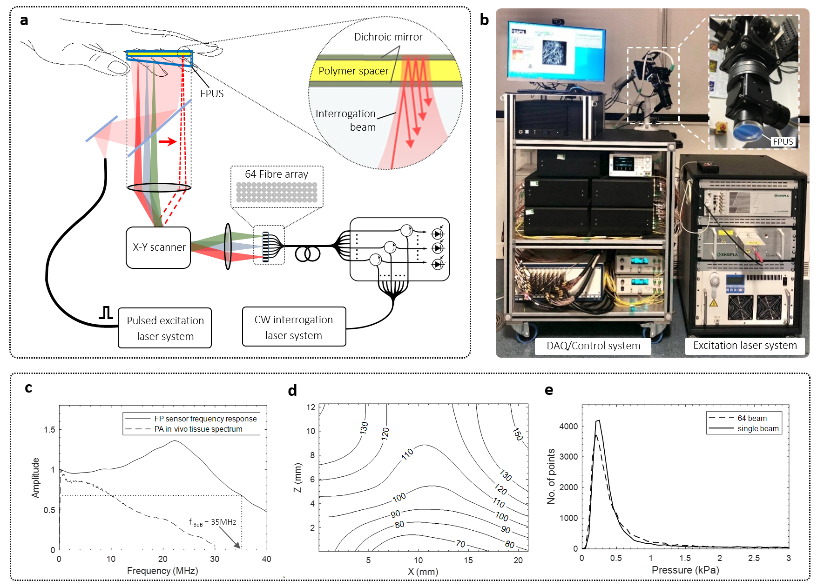

Figure 1 Multibeam Fabry Perot (FP) based photoacoustic tomography (PAT) scanner. (a) Schematic showing scanner read-out architecture and FP ultrasound sensor (FPUS) structure. (b) Photograph of scanner showing cart-based acquisition system, imaging head (inset) and OPO excitation laser system. (c) Frequency response of FP sensor with 24.6µm FPI spacer (f_{-3dB}=35MHz ) and acoustic frequency spectrum of photoacoustic signals generated in vivo in human palm (see Methods), (d) Lateral spatial resolution in microns for scan step size dx=dy=108 µm. (e) Noise-equivalent-pressure (NEP) distribution over 34,560 scan points for 64 beam scanner and 35,512 points for single beam scanner (see Methods).
The FP sensor also offers high sensitivity with small element size. Figure 1e shows a histogram of the noise equivalent pressure (NEP) distribution over a scan area of 21 x 19.5 mm². The modal NEP is 0.2 kPa over a 20MHz measurement bandwidth, similar to that achieved using a single interrogation beam illustrating negligible sensitivity degradation using the 64 beam read-out scheme. Notably this NEP was achieved using an interrogation beam spot diameter (1/e²) diameter of 70µm which to first approximation corresponds to the acoustic element size. The sensitivity of an equivalent sized broadband PVDF piezoelectric receiver would, for example, be approximately a factor of 50 lower, due to the scaling between piezoelectric sensitivity and element area⁶⁸.

Accelerated acquisition framework
The key technical advance that has been made relates to reducing the scan-time from the order of several minutes of previous FP sensor based scanners to a few seconds. To achieve this, two strategies were employed. The first involved accelerating the A-line acquisition rate by parallelising the sensor read-out and operating at higher PRFs than typically used for widefield PAT. In the second, a compressed sensing approach was adopted permitting sub-sampling of the acoustic detection aperture and thus a reduction in the number of A-lines required to form an image.
The parallelisation of the FP sensor read-out was achieved using a multibeam scanner in which an array of N interrogation beams is scanned across the sensor; N=16 or N=64, with the latter most commonly used and assumed in the following description. As shown in figure 1(a), the output of the interrogation laser system (see Methods) is divided into 64 single mode 9µm core fibres using a passive fibre splitter. Each fibre is input to a fibre circulator and recombined to form a fibre bundle comprising four rows of sixteen fibres with a core-to-core separation of 80µm. The divergent output of each fibre in the bundle is incident on a lens that collimates the beams and form a pivot point at the input of a 2-axis conjugate galvanometer based scanner. The output of the scanner is focused on to the FP sensor plane, resulting in an array of 64 focused spots (1/e² diameter=70µm), each separated by 318µm. The 64 beams are reflected from the sensor, back through the scanner, re-coupled into their respective single mode fibres and delivered via circulators to individual InGAs photodiode-transimpedance amplifier units. By scanning the array of 64 beams across the sensor surface and recording the acoustically-induced time-varying optical power modulation simultaneously on all 64 channels at each scan point, a map of the incident photoacoustic field can be recorded. In all cases single-shot acquisition without signal averaging was used.
Parallelising the detection in this way sets a specific technical challenge. For optimum sensitivity, the interrogation laser is tuned to a wavelength that aligns with the edge of the FPI cavity resonance, denoted the optimum bias wavelength λ_{b}³⁹. Since the interrogation laser wavelength is identical for all 64 beams, the FPI polymer spacer optical thickness uniformity needs to be sufficiently high that λ_{b} is spatially invariant to within ~0.1 nm over the 5.1 x 1.3 mm² area dA_{b} on the sensor occupied by the array of 64 focused beams. For a typical spacer thickness of 25µm, this requires a thickness uniformity to within 1.6 nm over dA_{b}, a non trivial requirement for polymeric films. If this condition is not met λ_{b}, and thus the acoustic sensitivity, will vary from one beam to the next, compromising the reconstructed image SNR. Spacer thickness uniformities as low as 0.1nm over 1cm² were achieved, comparable to that achievable with a high quality glass etalon. This level of thickness uniformity comfortably surpasses the requirement for λ_{b} parity over dA_{b} as evidenced by figure 1b, which shows the spatial distribution of the NEP of a 64 beam read-out system is comparable to that of single beam read-out.
Fast acquisition was further enabled by the use of high PRF excitation lasers. Frequency doubled Nd:YAG pumped Type 2 OPO laser systems, emitting 5ns pulses at PRFs up to 200 Hz were used for most imaging studies (see Methods). In addition a custom Yt fibre laser⁵³ operating at a PRF of 1kHz emitting 20 ns pulses was used to demonstrate the maximum A-line rate that the scanning and acquisition hardware could provide. The combination of parallelising the sensor read-out and operating at these PRFs, enabled significant A-line rate acceleration. Depending on N and the PRF, A-line rates between 1,400 and 64,000 A-line/s were achieved, compared to the 50 A-Lines/s of early generation single-beam FP scanners.
The potential to reduce the scan-time by randomly sub-sampling the scan area to reduce the total number of scan points was also evaluated. By exploiting the data redundancy in the photoacoustic wavefield within a compressed sensing framework, sub-sampling factors of 50%, 25% and 12.5% were used achieving commensurate reductions in scan-time.
These developments have significantly reduced the time required to acquire a 3D image data sets; depending on the imaging parameters used, scan-times on a scale of seconds to hundreds of ms can now be achieved.

Image reconstruction
In order to reconstruct an image from the measured photoacoustic time-series, an efficient k-space backprojection algorithm was used. By employing a fast C++ CPU optimised computational implementation, image reconstruction time has been reduced by a factor of 5 over a previous Matlab implementation. Reconstruction time depends on scan area, spatial sampling interval and the number of points in the time-record. For example, for a scan area of 21 x 19.5 mm², dx=dy=108µm and a record length of 600 time points, reconstruction time was 0.8s, decreasing to 0.48s for a 15 x 15 mm² scan for the same spatial-temporal sampling intervals using a desktop PC. This implementation was used to reconstruct all images except those reconstructed from sub-sampled data for which an iterative model-based approach was used⁴⁷ (Methods).

High fidelity 3D in vivo static vascular imaging
To demonstrate the rapid, high fidelity volumetric imaging capabilities of the scanner, images of normal vascular anatomy and haemodynamic events were acquired using healthy adult volunteers as research participants (see Methods). Acquiring an image is procedurally similar to performing a conventional clinical ultrasound scan. The probe head is first positioned above the approximate location of interest and a bolus of ultrasound gel inserted between the FP sensor and the skin to provide acoustic coupling. Following any small adjustments to the probe head position, the scan is begun and an image data set acquired. Figure 2 shows a range of maximum intensity projections (MIP) of 3D image data sets acquired in this way at different positions on the hand and wrist. These images were reconstructed from 34,560 photoacoustic A-lines recorded over a scan area of 21 x 19.5 mm² in 108µm steps. The PRF-limited A-line rate was 6,400 A-lines/s resulting in a total scan time T=5.4s. By contrast, early generation single-beam FP scanners³⁹ would have required T>10 minutes to perform an identical scan.

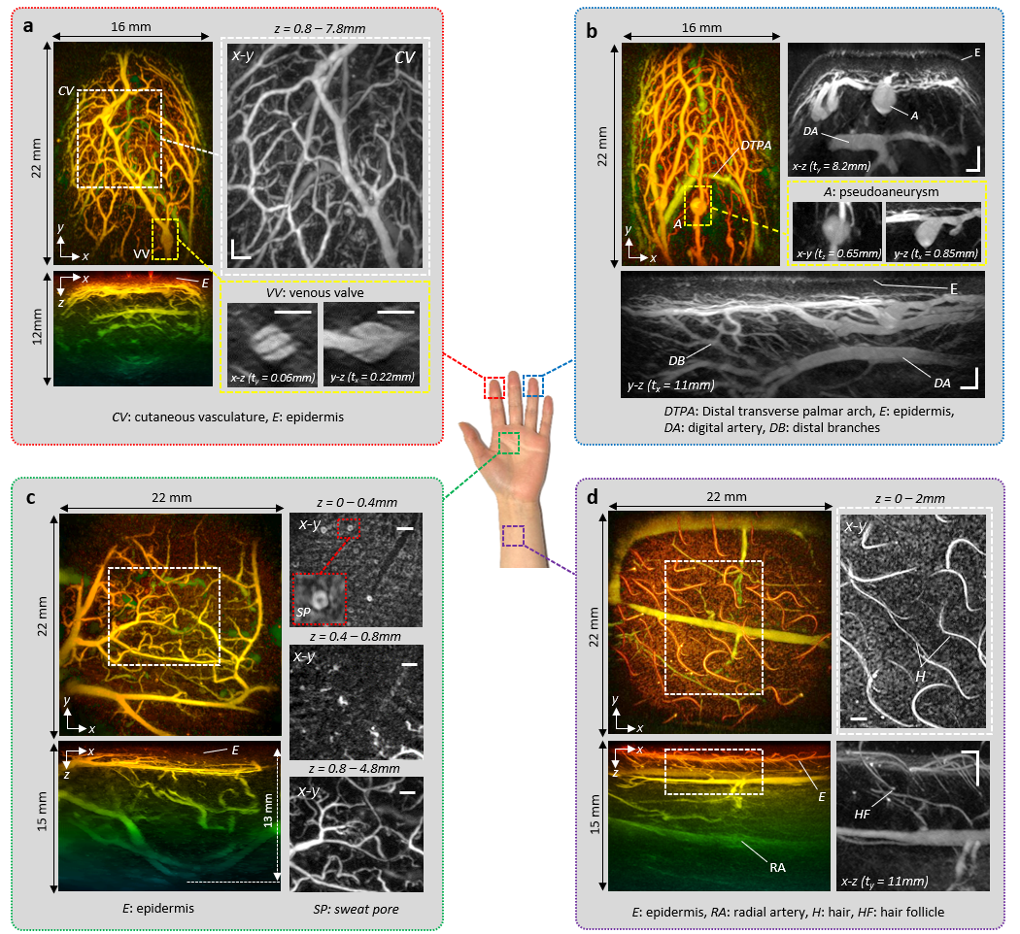

Figure 2 PAT images of the hand and wrist regions; (a) Index finger-tip. Left; x-y and x-z depth-to-colour encoded MIPs. Right, expanded view greyscale MIPs showing en-face view of cutaneous vascular (CV) anatomy and cross-sectional views of a venous valve (VV). (b) Ring finger-tip. Left; x-y depth-to-colour encoded MIP. Right; expanded view greyscale MIPs showing cross-sectional view of dermal microvascular anatomy, epidermis (E), digital artery (DA) and pseudoaneurysm (A) and Lower; expanded view y-z greyscale cross-sectional MIP showing distal branches (DB) and digital artery (DA). (c) Palm region. x-y and x-z depth-to-colour encoded MIPs showing vascular anatomy to a depth of 13mm. Right; expanded view x-y en-face greyscale MIPs for three different depth ranges for region indicated by white dotted box. (d) Wrist region. x-y and x-z colour-depth encoded MIPs, the latter showing the radial artery (RA). Right expanded view greyscale MIPs of region indicated by white dotted box showing hair (H) and hair follicles (HF). Scale bars: 1mm. t_{x} and t_{y}: slice thicknesses of y-z and x-z greyscale MIPs respectively. Imaging parameters: λ=850nm, dx=dy=108µm, dt=16.67ns, PRF=100Hz, N=64, A-line rate: 6400 A lines/s, scan-time: T=5.4s.

As figure 2 shows, the scanner can provide detailed volumetric images of the microvasculature to depths approaching 15 mm. The images of the index and ring finger-tips (figures 2a and 2b) show a superficial layer (E) less than 200µm thick. This is the predominantly avascular epidermis with the contrast provided by melanin rather than haemoglobin absorption - see Suppl. Figure 2 for additional depth-resolved visualisations. Beneath the epidermis, at a depth of approximately 0.5mm, dense networks of small vessels within the superficial papillary plexus are visible. In this region, individual vessels with reconstructed lateral and vertical dimensions down to 80µm and 50µm respectively are visible. At greater depths, the larger vessels in the reticular plexus, the distal transverse palmar arch (DTPA) and the digital artery (DA) in the hypodermis can be seen (figure 2(b)). Other structures include venous microvalves (VV) in the superficial papillary plexus, most evidently in the lower right x-z and y-z greyscale images in figure 2a. These images reveal the V-shaped structure characteristic of the internal folds that serve as the leaflets of a bicuspid venous valve, also observed in TEM images of resin casts of valves but not previously visualised in vivo in 3D in sub-mm venules. Another distinctive vascular structure is the berry shaped feature protruding from a superficial vessel as shown in figure 2(b), possibly a pseudoaneurysm (A) or saccular dilation. The image of the palm and wrist regions (Figures 2c and 2d) show a thicker epidermis, a less dense superficial vasculature, large vessels such as the radial artery (figure 2d) and greater penetration depth with discernible vascular anatomy at a depth of 13mm. Also visible are non-vascular structures including sweat pores, skin sulci, hair and hair follicles.
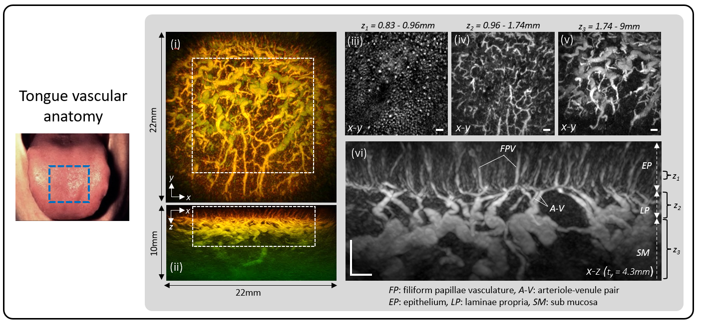
Figure 3: PAT image of the tongue dorsum. (i) x-y and (ii) x-z depth-to-colour encoded MIPs. Greyscale x-y MIPs of region indicated by dotted white rectangle in (i) for (iii) 0.13mm thick slice through the epithelium (EP), z=0.83mm to 0.96mm. (iv) 0.78mm thick slice corresponding to laminae propria (LP), z=0.96 to 1.74mm. (v) 7.26mm thick slice through submucosa (SM) and muscle, z=1.742mmm to 9mm. (vi) Expanded view greyscale x-z MIP of region indicated by white dotted rectangle in (ii) showing filiform papillae (FP) capillary loops, arteriole-venule pair (A-V) and supplying vasculature. Scale bars: 1mm. t_{y}: slice thicknesses of x-z greyscale MIP. Imaging parameters: λ=875nm, dx=dy=108µm, dt=16.67ns, PRF=100Hz, N=64, A-line rate: 6400 A lines/s, scan-time: T=5.4s.

Other regions of the body that exhibit distinctive vascular anatomy were scanned to demonstrate the versatility of the scanner. Figure 3 shows an image of the dorsal region of the tongue illustrating the rich diversity of vascular architectures, orientations and length scales that can

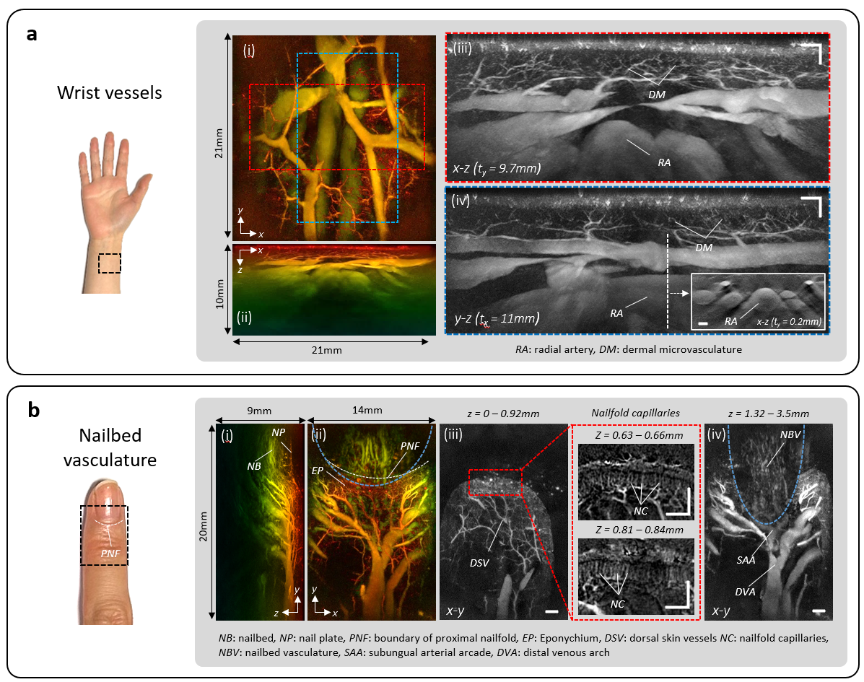
Figure 4: PAT images of the wrist and nailbed vasculature acquired in high resolution scan mode. (a) Wrist region, (i) x-y and (ii) x-z depth-to-colour encoded MIPs, (iii) x-y and (iv) y-z greyscale MIP slices of regions indicated by dotted red and blue rectangles in (i) showing fine dermal microvasculature (DM), radial artery (RA) and large wrist veins. Inset: x-z greyscale MIP showing cross-sectional view of the radial artery and adjacent veins in the plane indicated by the white dotted line in (iv). (b) Nailfold and nailbed region of the finger, (i) y-z depth-to-colour encoded MIP showing dermal vasculature, nail plate (NP) and nailbed (NB). (ii) x-y depth-to-colour encoded MIP showing en-face view of supplying vascular tree and eponychium (EP). White dotted line represents the boundary of the proximal nailfold (PNF). (iii) x-y MIP greyscale slice (z=0 – 0.92mm) revealing dorsal skin vessels (DSV) and nailfold capillary (NC) region. Right: expanded view of red dotted rectangle showing layers of nailfold capillaries at two different depths. (iv) x-y MIP greyscale slice (z=1.32 - 3.5mm) showing nailbed vasculature, subungual arterial arcade (SAA) and distal venous arch (DVA). In (ii) and (iv), the region visualised within the blue dotted line lies beneath the nailplate. To account for the higher speed of sound in the nail, this region was reconstructed using a different sound speed (c=1650 m/s) to the surrounding region (c=1547 m/s) enabling improved visualisation of the vasculature beneath the nailplate. Scale bars: 1mm. t_{x} and t_{y}: slice thicknesses of y-z and x-z greyscale MIPs respectively. Imaging parameters: λ=850nm, dx=dy=50µm, dt=16.67ns, PRF=100Hz, N=64, A-line rate=6400 A lines/s, scan-time T=29s.
visualised. The superficially located near-vertical capillaries in the filiform papillae and their supplying
arteriole-venule pairs, the dense network of microvessels in the lamina propria and the larger mm-scale horizontally-aligned supplying vessels in the underlying sub-mucosa and muscle are all visible. To acquire even more detailed images, a high resolution scan mode in which the step size was reduced to 54µm was used. Figure 4 shows an image of the vessels in the wrist acquired in this mode. At depths below 2mm, the fine dermal microvasculature (DM) can be seen. In this region, individual vessels with reconstructed lateral and vertical dimensions down to 45µm and 35µm respectively are visible. In addition, much larger mm-scale vessels such as the radial artery can be seen. It is notable that the interiors, as well as the edges, of these vessels are clearly visualised, most apparently in the inset x-z MIP in Figure 4a(iv). This is a consequence of the broad bandwidth of the FP sensor which extends down to 50kHz enabling detection of the low acoustic frequencies required to accurately reconstruct mm-scale features. By contrast, images acquired by piezoelectric based PAT scanner tend to visualise only the boundaries of large vessels, a consequence of the narrower bandwidth of the piezoelectric ceramic or composite receivers used in these systems which provide poor low frequency sensitivity. A similar high resolution scan was performed on the upper side of the finger in the nailbed area further illustrating the diversity of vascular anatomy that can be visualised. The major digital vessels such as the distal venous arch (DVA) and those constituting the subungual arterial arcade (SAA) can be seen. In addition, small microvessels, including the nailfold capillaries which can serve as markers of conditions such as rheumatoid arthritis or Reynaulds phenomenon are visible. As in the wrist dermis, vessels with reconstructed lateral and axial dimensions down to 45µm and 35µm respectively are discernible in this region.
These results show that the scanner can provide detailed 3D vascular images of comparable, if not better, quality than previous FP scanners but with acquisition times of the order of seconds rather than minutes.

Accelerated acquisition modes (602): The short scan-times achieved for the images shown in figures 2-4 enabled acquisition of high quality images without significant motion related-artefacts. However,
faster acquisition is desirable in some circumstances, for example for visualising haemodynamic events. To achieve this, images were acquired using excitation lasers operating at higher PRFs than typically used in PAT and exploiting compressed sensing principles. The results of the former are shown Figure 5(a) which shows images of a 14 x 14mm² region on approximately the same region of the palm at three different PRFs. The images acquired at 100Hz and 200Hz PRFs were obtained at 875nm using an OPO laser system resulting in PRF-limited A-line rates of 6,400 A-lines/s and 12,800 A-line/s and acquisition times of 3.2s and 1.6s respectively. There is a modest reduction in image SNR at 200Hz due to the lower pulse energy used in order to remain below the MPE. To demonstrate that the scanner hardware can operate at even higher PRFs, an image was obtained using a PRF of 1kHz provided by a custom-designed, large core Yb fibre laser based on a MOPA architecture (see Methods) operating at 1064nm. The A-line rate achieved at this PRF was 64,000 A-lines/s, resulting in a scan-time of T=0.3s. Image quality appears not be excessively compromised, given the non-optimal excitation wavelength and low pulse energy of the laser which resulted in a fluence more than one order of magnitude lower than the MPE.
There is inevitably a limit to the scan speed that can be achieved by increasing the PRF to in order to increase the A-line rate. This is dictated by the galvanometer response time, data acquisition sampling and transfer rates, the availability of high PRF mJ-scale ns pulsed lasers and, perhaps most importantly, MPE considerations. The use of spatially sub-sampled data within a compressed sensing framework provides an opportunity to circumvent these limitations. It is based on the notion that the spatial complexity of photoacoustic images is modest and thus conventionally uniformly sampled photoacoustic data contains an element of redundancy. This redundancy can be exploited to reconstruct an image without excessively compromising image SNR by randomly sub-sampling the acoustic detection aperture to avoid systematic biases and employing an iterative model-based variational image reconstruction approach which implicitly imposes a sparsity constraint⁴⁷. Since this image is formed from fewer but carefully chosen measurements (so as to maximise their information content), the scan-time T is reduced accordingly. The results of using this approach (see Methods) are illustrated in Figure 5(b) which shows images reconstructed using different sub-sampling factors. These images were obtained by randomly scanning the interrogation beam array in a non-overlapping fashion to acquire a fully sampled (100%) photoacoustic time-series data set with a scan time T=5.4s nd image SNR=33dB. Thereafter, the sub-sampled data was obtained by extracting the first 12.5%,
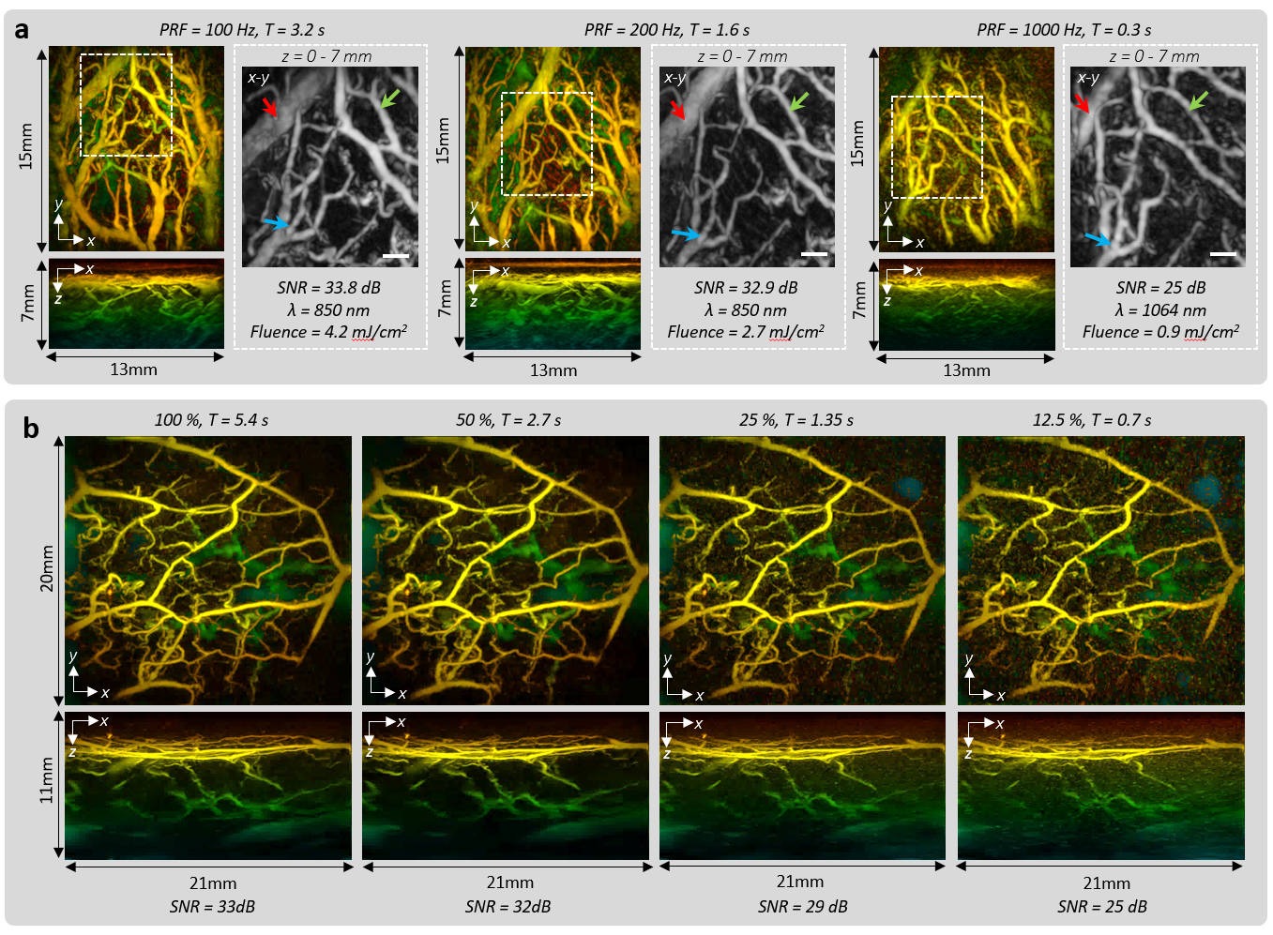
Figure 5: Accelerated PAT acquisition modes: (a) Images of the vasculature acquired at PRFs of 100 Hz, 200 Hz and 1000 Hz. The corresponding A-line rates were 6400, 12,800 and 64,000 A-lines/s resulting in scan-times of T=3.2s, T=1.6s and T=0.3s respectively. The white dotted rectangle represents the region of the vasculature common to all three images; it is within this region that the SNR is estimated. The greyscale x-y MIPs show expanded views of this region with the red and blue arrows depicting common blood vessels. (b) Images acquired at λ=850nm using fully sampled data (100%) and spatially sub-sampled data with sub-sampling factors of 50%, 25% and 12.5% and corresponding scan times of T=5.4s, T=2.7s, T=1.35s and T=0.7s respectively. A-line rate=6400 A-lines/s. Scale bars: 1mm. Imaging parameters: dx=dy, dx=dy=108µm, dt=16.67ns, N=64.
25% and 50% of the recorded data from the 100% data set with corresponding scan times of T=0.7s, T=1.35s and T=2.7s and image SNRs of 25 dB, 29 dB and 32 dB. As figure 5b shows, SNR and fidelity scale inversely with sub-sampling factor, although, even when using just 12.5% of the fully sampled data, the main features of the tissue vasculature remain visible. However, the reductions in scan-time come at the cost of increased reconstruction time due to the need to compute multiple iterations; for example the reconstruction time was >1 hour for the images in Figure 5 compared to <1s for the images in Figure 2 which were reconstructed using the single-step k-space method⁴⁸. The use of learned iterative schemes may however provide a route to accelerating convergence and reducing reconstruction time

2D dynamic imaging (500)
The system can provide a 2D video-rate imaging mode for visualising dynamic physiological events or to rapidly search for a region of anatomical interest in real-time prior to switching to the 3D imaging mode. To acquire a 2D image, the 4 x 16 interrogation beam array is scanned along a line on the FP sensor, with the long axis of the array aligned along the scan line. The photoacoustic signals acquired can thus be regarded as equivalent to those acquired from a 1.5D ultrasound array composed of 4 x 16 x m elements, where m is the number of scan steps along the line scan. By performing depth-dependent synthetic receive focussing in the elevation plane of this notional 1.5D array, out-of-plane photoacoustic signals are rejected and the image slice thickness minimised (Figure 6a(i)). To demonstrate the video rate 2D imaging capability of the system, the probe was place on the wrist of a volunteer and translated over the skin surface whilst acquiring images as shown in Movie 1. Figure 6a(ii) shows a sequence of 5 frames extracted from this movie corresponding to different probe positions. Several blood vessels and their change in relative lateral position as the probe is moved from right to left can be seen. To acquire these images, the interrogation beam array was scanned along a 15.65 mm long line in steps of 163µm and an excitation laser PRF of 200Hz was used. Hence, the A-line rate was 12,800 lines/s resulting in a single frame scan-time of 30ms and thus a frame rate of 33fps.
In a second experiment, the radial artery (Figure 6a(iii)) was imaged at 33fps enabling the time-varying change in its dimensions due to the pulsatile motion of the blood flow to be visualised. This is illustrated in Movie 2 with Figure 6a(iii) showing a plot of the oscillatory variation in the minor axis of the compressed artery at a frequency corresponding to the physiologically normal 70 beats per minute. In the examples shown in Figure 6a the photoacoustic time-series data were downloaded following the scan and the images reconstructed and visualised offline. Movie 3 shows an example where images of the skin vasculature were reconstructed and visualised online in real time as the probe head is translated across the skin surface. This incurs a modest time-penalty compared to offline reconstruction due to the limited data transfer speed from the memory of the RF digitiser card resulting in a reduced frame rate of 25 fps.

3D dynamic imaging (769)
To illustrate the dynamic 3D imaging capability of the system, two experiments were undertaken. In the first, a sequence of images was acquired as the probe head was translated over the surface of the finger-tip and are shown Movie 4. Five representative frames reconstructed from the data used to produce this movie are shown in figure 5(b). They correspond to different time points during the motion of the probe with the white dotted lines showing the translational trajectory of a pair of vessel bifurcations (white arrows). To acquire the data for these images, the scan area was continuously scanned over a period of 12s according to a pre-determined randomised spatial pattern acquiring a total of 153,600 A-lines. Each of the images in figure 5b was reconstructed from 7680 A-lines acquired in 0.6s (1.67 fps). To provide a smooth dynamic visualisation in Movie 4, a sliding window advanced in increments of 10% was applied to the entire measured photoacoustic data set. Thus, the first frame was reconstructed from the first 7680 A-lines. To reconstruct the second frame, the first 768 A-lines (the first 10%) were replaced by the A-lines numbered 7681 to 8449 (the next 10%) and so on with the window advancing incrementally by 10% until it reaches the end of the complete 153,600 A-line measured data set. Movie 4 therefore comprises 200 frames with a refresh frame rate of 16.7 fps. In this example, the reconstruction and visualisation of the images was performed offline following acquisition of the complete data set. However, real-time dynamic imaging can also be performed online in 3D to facilitate ROI localisation and probe positioning. This is shown in Movie 5 which shows the probe head being translated across the finger-tip but in this case the 3D images are reconstructed and displayed in real-time at a frame rate of 1.67 fps
In the second experiment, an invoked haemodynamic response was visualised. This was achieved by placing an inflatable cuff around the upper arm of a volunteer and inflating it to a pressure of 230mmHg for 5 seconds to produce an arterial occlusion. By temporarily restricting blood flow in the arteries supplying the hand, perfusion in the downstream digital microvasculature is reduced. Following the release of the cuff, the vasculature is rapidly re-perfused achieving a steady-state thereafter. These changes were visualised by placing the forefinger tip on the sensor and continuously randomly scanning the sensor for a period of 12 seconds. Movie 6 shows the complete image data set,
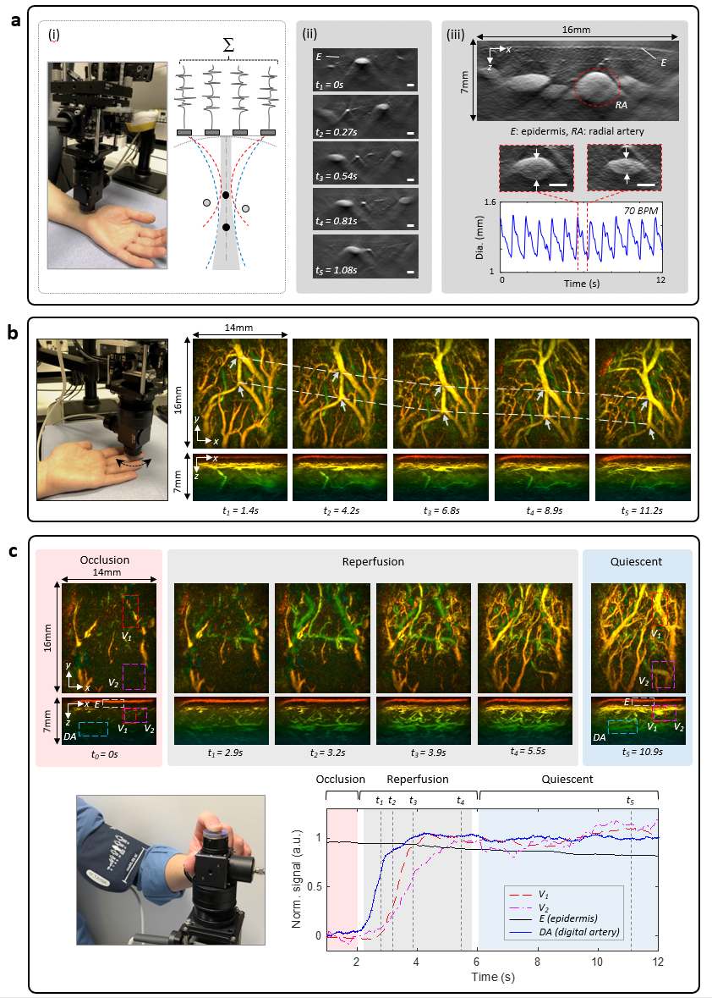
Figure 6: Dynamic PAT imaging: (a) Video rate 2D imaging, (i) Left; probe head positioned on wrist. Right; illustration of elevational receive beamforming, (ii) sequence of images of blood vessels in the wrist region acquired at different time points at a frame rate of 33 fps as probe head is moved across the skin surface from right to left; see Movie 1 for complete image sequence. (iii) Top; image of radial artery (RA) and adjacent veins in the wrist. Centre; two images of radial artery acquired 0.8s apart showing change in dimensions due to pulsatile motion of blood flow; see Movie 2 for complete image sequence. Lower; Oscillatory time-variation of radial artery size at 70 beats per minutes (BPM). Single frame scan-time T=30ms. (b) Real-time 3D imaging. Images acquired at 6 different time points at a frame rate of 1.67 fps as the finger-tip is translated across the probe head. The pair of white dotted lines shows the translational trajectory of two vessel bifurcations identified by white arrows. See Movie 4 for complete image sequence. (c) Haemodynamic response due to arterial cuff occlusion. Top; images of finger-tip vasculature acquired at 5 different time points at 1.67 fps showing occlusion, reperfusion and quiescent phases. See Movie 5 for complete image sequence. Lower; time course of vascular signal in ROIs delineated by dotted rectangles corresponding to two vessel regions (V1 and V2), the epidermal region (E) and the digital artery (DA). Scale bars: 1mm. Imaging parameters: λ=850nm, PRF=200Hz, N=64, A-line rate 12,800 Lines/s, dx=dy=163µm, dt=16.67ns

reconstructed and visualised with a 16.7 fps refresh frame rate using the previously described 10% sliding window method. Figure 5(c) shows a sequence of six image frames corresponding to the occlusion, re-perfusion and quiescent periods. In addition, the temporal evolution of the mean image intensity within ROIs corresponding to the epidermis (E), two regions of the vasculature (V1 and V2) and the digital artery (DA) are plotted. These results show that during the occlusion period, the contrast exhibited by the vasculature is weak. When the cuff is released, rapid re-perfusion occurs and the contrast increases attaining its normal level within 2-3 seconds. The rate of increase is similar for all three vascular ROIs (V1, V2 and DA) although the onset time for each is different; the signal corresponding to digital artery (DA) is the first to increase, as expected since it is the arterial flow that resumes first, followed by V1 and V2. Notably, the signal corresponding to the epidermis is relatively constant over time which is consistent with the assumption that the contrast in this region is predominantly non vascular, originating from dermal melanin rather than blood. The ability to visualise hemodynamic events in this way could enable the study of time-varying physiological responses such as post-occlusive reperfusion, pressure-induced vasodilation or thermal reflex events. This could be relevant to the clinical assessment of patients with peripheral vascular disease associated with diabetes who can exhibit impaired microvascular reactivity which has been associated with increased risk of ulceration.

Exploratory clinical case studies (1745)
To illustrate how the scanner could be used clinically, exploratory case studies on patients with suspected vascular changes associated with peripheral vascular disease, skin inflammation and rheumatoid arthritis were undertaken (see Methods); These are small scale preliminary studies not intended to provide a comprehensive clinical validation of the technology but signpost potential areas of application that warrant future more comprehensive clinical studies.

Peripheral vascular disease: Peripheral vascular disease (PVD) affects more than 25 million individuals across the USA and Europe and is a complication of diseases such as diabetes that can lead to compromised perfusion resulting in pain, tissue damage and in severe cases limb amputation. While larger vessels can be visualised using conventional duplex ultrasound or MRI, the small vessel changes implicated in PVD that can be early indicators of disease often can not be visualised in sufficient detail. Hence there is a need for novel sensitive label-free imaging techniques that can detect early stage microcirculatory changes and prompt intervention before the onset of tissue damage. A previous preliminary study suggests PAT could potentially meet this need²⁰. To illustrate the potential utility of the scanner in this context, the feet of patients at risk of small vessel PVD were imaged in the vicinity of the Dorsalis Pedis Artery (DPA). Following clinical examination, the microcirculation in the right foot of a patient (denoted Patient 1) was assessed as normal whereas the left foot was symptomatic of impaired perfusion. The PAT image of the unaffected right foot of this patient (Figure 7(a)(i)) appears broadly consistent with the images acquired in disease-free volunteers. The affected left foot (Figure 7(a)ii) however exhibits differences with evidence of venous valve dilation and vessel tortuosity which has been linked to microvasculopathy associated with PVD. Figures 7(b) and (c) show PAT images of two patients with Type 2 diabetes which is commonly associated with PVD. Patient 2 was diagnosed with
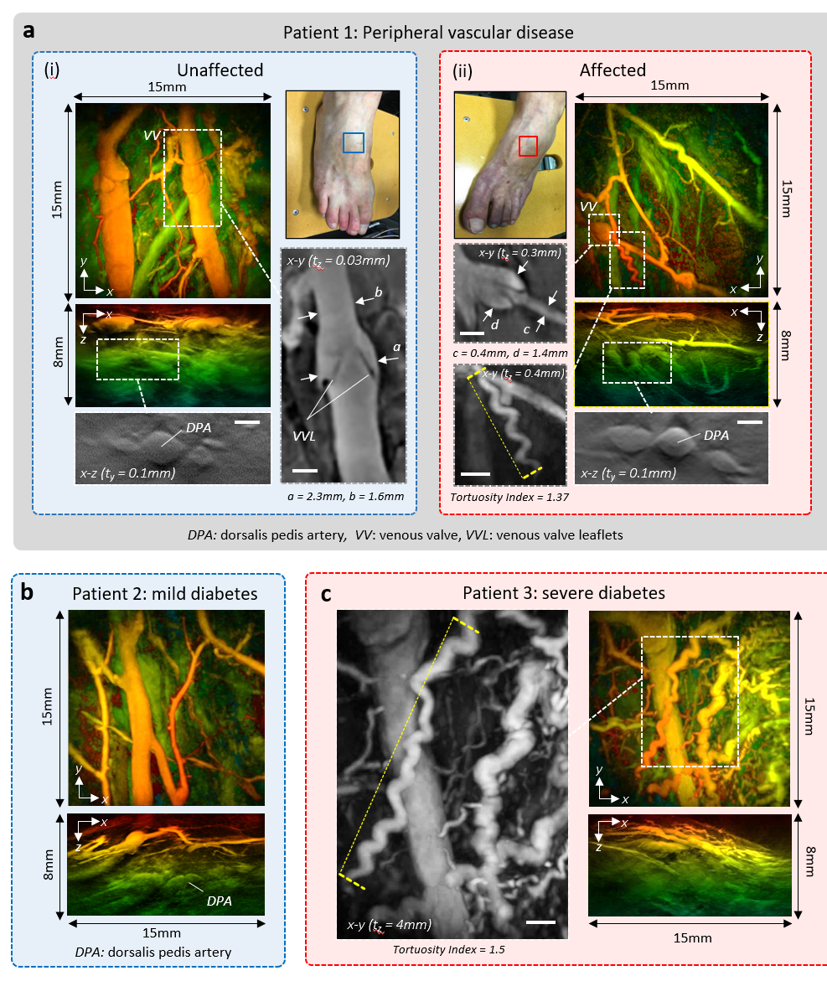
Figure 7: PAT images of feet of patients with suspected peripheral vascular disease (PVD). (a) Patient 1: (i) Unaffected right foot. Left; x-y and x-z depth-to-colour encoded MIPs. Expanded view greyscale MIPs: Lower; x-z MIP showing Dorsalis Pedis Artery (DPA). Right; x-y MIP showing venous valve. (ii) Affected left foot. Right; x-y and x-z depth-to-colour encoded MIPs. Expanded view grayscale MIPs showing Left; venous valve. Lower; corkscrew vessel, Tortuosity Index=1.37 (measured over length of vessel indicated by yellow dotted line), Lower right: greyscale x-z MIP showing DPA. (b) Patient 2: mild Type 2 Diabetes, x-y and x-z depth-to-colour encoded MIPs, (c) Patient 3: severe Type 2 Diabetes, Right; x-y and x-z depth-to-colour encoded MIPs, Left; expanded view grayscale MIP showing disorganised irregular vasculature and corkscrew vessel with Tortuosity Index=1.5 (measured over length of vessel indicated by yellow dotted line). Scale bars: 1mm. t_{x} and t_{y}: slice thicknesses of y-z and x-z greyscale MIPs respectively. Imaging parameters: λ=850, dx=dy=108µm, dt=16.67ns, PRF=100Hz, N=16, A-line rate: 1400 A lines/s, scan-time T=15s.

mild disease and exhibits an apparently normal vascular morphology (Figure 7(c)). The PAT image of Patient 3, who was diagnosed with more severe disease, reveals a more disorganised, irregular microvascular architecture with several tortuous vessels, some exhibiting a corkscrew structure (Figure 7(d)) which in retinal vessels has been linked with diabetes,. The ability to visualise the lower limb microvasculature in detail in this way could be used to study small vessel-PVD linked to diseases such as diabetes with a view to identifying clinically-relevant structural microvascular biomarkers for informing diagnosis and treatment.

Inflammation: Visualising angiogenesis induced by inflammation is relevant to the assessment of a variety of disease and injury processes, amongst them dermatological conditions, cancer and rheumatoid arthritis. To illustrate the potential application of the scanner in this context, it was used to image three examples of inflammation-driven neovascularisation. Figure 8(a) shows the first of these. Images were acquired longitudinally at 5 different time points of a region of superficial skin inflammation around a raised papule on the forearm following a suspected inspect bite. Images were acquired over 7 days during which the papule was judged to be visible by eye. An additional image was acquired 38 days later when the inflammation had fully subsided. The image on day 1 was acquired when the inflammation was judged to be at its apogee. It reveals a dense, chaotic microvascular architecture in the region of the papule that extends from the epidermis to the hypodermis to a depth of approximately 4 mm. Visual inspection of the sequence of images in figure 8(a) shows the number of vessels in this region gradually diminishing to the presumed baseline. This is evidenced quantitatively by the reduction in the vascular density V_{s} of the inflamed region from 28% to 8%, where V_{s} is the percentage of the image volume occupied by vessels (see Methods). These results illustrate how the scanner can visualise and quantify changes in the three-dimensional microvascular architecture of the skin over time, attributes that could be relevant to the clinical assessment of inflammatory skin disorders such as eczema or dermatitis²¹.
In the second example, the scanner was used to visualise the skin inflammation linked to breast cancer. This can arise when a tumour provokes an inflammatory response that produces skin neovascularisation in, for example, the nipple areolar complex (NAC) region. In patients with locally advanced disease of this nature, even if the tumour is beyond the penetration depth range of the scanner, the neovascularisation can be relatively superficial (<5mm). This is illustrated in figure 8(b). Figure 8(b)(ii) shows PAT images acquired in different areas (B2, B3, B4) of the NAC region in a patient with a tumour in the right breast, identified via diagnostic ultrasound and MRI. Compared to the PAT image of the unaffected left breast (Figure 8(b)(i)), the images of the right breast reveal an increase in contrast due to skin neovascularisation, also evident in the MR images but not via ultrasound examination or visual inspection. Image contrast in the inflamed region was quantified using V_{s} as described above with the ROI selected to exclude the skin and nipple. For the unaffected left breast, V_{s}=6% whereas the mean V_{s} of the three images of the inflamed region in the right breast was 26%. Although the objective was not to visualise the tumour, its boundary is discernible in the x-z MIP corresponding to position B4; Suppl. Fig 3 provides additional visualisations of this region showing the tumour and surrounding supplying vasculature. The ability to visualise inflammatory responses in this way could find broad application, for example in the study of the aetiology of tumour driven inflammation and angiogenesis in cancer.
In the third example, the scanner was used to image the joints of patients with rheumatoid arthritis. This is a disease of the joints characterised by inflammation of the synovial membrane which affects >100 million people worldwide (REF), causing discomfort, immobility and, if left untreated, loss of joint use. The inflammation produces neovascularisation that could potentially serve as a marker of
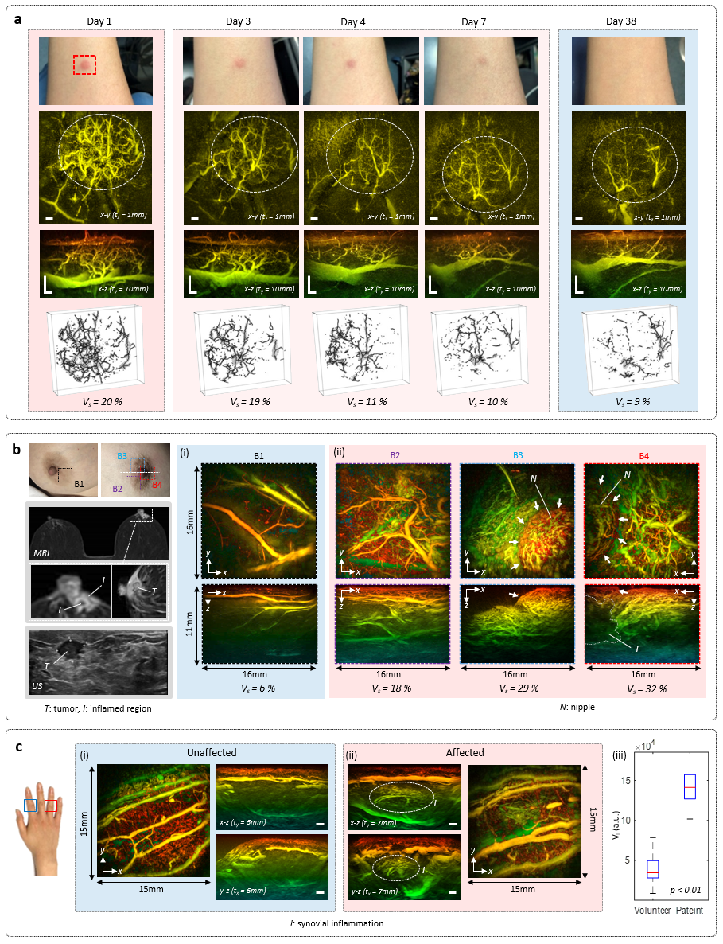
Figure 8: PAT images of inflammatory responses. (a) Inflammation around raised skin papule over 38 days. x-y depth-to-colour encoded MIPs (1 mm slice thickness; z=0.5mm – 1.7mm – check) and x-z MIPs. The inflamed regions are indicated by the dotted white ellipses. Photograph in blue panel is representative of imaged region at day 38 but was taken non-contemporaneously at a later date. Lower row of images show 3D skeleton representations of vascular architecture used to estimate vascular density, V_{s}. Scale bars: 1mm. t_{z} and t_{y}: slice thickness of x-y and x-z greyscale MIPs. Imaging parameters: λ=850, dx=dy=108µm, dt=16.67ns, PRF=100Hz, N=64, A-line rate: 6400 A lines/s, scan-time T=5.5s. (b) Inflammation in nipple areolar complex (NAC) region of patient with tumour in right breast. Left panel: Photographs, MRI and ultrasound images. MRI images; top; full view, bottom; expanded view around NAC region of affected right breast showing inflamed region (I) and tumour (T). Ultrasound image showing tumour. (i) PAT image (x-y and x-z depth-to-colour encoded MIPs) of region B1 on unaffected breast showing low microvascular density, V_{s}=6%. (ii) B2, B3 and B4 are locations on the affected breast showing increased vascular densities, V_{s}= 18%, 29%, 32% respectively. White arrows delineate nipple (N). White dotted line on B4 x-z MIP image represents presumed tumour boundary; see Suppl Inf. Fig X for additional tumour visualisation. Imaging parameters: λ=850, dx=dy=108µm, dt=16.67ns, PRF=100Hz, N=16, A-line rate: 1400 A lines/s, scan-time T=15s. (c) Inflammation in synovial region of finger joints in patient with rheumatoid arthritis. (i) Unaffected proximal interphalangeal joint on index finger. x-y, x-z and y-z depth-to-colour encoded MIPs. (ii) Affected proximal interphalangeal joint on ring finger. x-y, x-z and y-z depth-to-colour encoded MIPs. x-z and and y-z MIPs show increased vascular contrast in inflamed synovial region (indicated by white dotted ellipses). Right: Box and whisker plot showing differences in mean vascular signal V_{I} for unaffected (45 joints from 5 healthy volunteers) and affected (19 disease active joints from 7 patients) joints. t_{x} and t_{y}: slice thicknesses of y-z and x-z greyscale MIPs respectively. Imaging parameters: λ=850, dx=dy=108µm, dt=16.67ns, PRF=100Hz, N=16, A-line rate: 1400 A lines/s, scan-time T=15s. All scale bars: 1mm.

disease severity but is inadequately visualised by existing modalities such as conventional B-mode and Doppler ultrasound. This has led to suggestions that PAT could play a role in the clinical assessment of rheumatoid arthritis^{22,23,24.}. To illustrate the potential application of the scanner in this context, images of suspected inflamed hand joints were acquired. Figure 8(c) shows examples of PAT images of the interphalangeal joints in a patient with a diagnosis of rheumatoid arthritis in the right hand; the diagnosis was based on the observation of synovial thickening and blood flow observed under clinical Duplex ultrasound examination, a biochemical inflammatory marker and patient-reported symptoms. Consider the vertical x-z and y-z MIPs in figure (8)(c). Compared to the image of the unaffected joint in the left hand of the same patient (figure 8(c)(i)), the affected joint in the tendon region (indicated by the white dotted ellipse in figure 8(c)(ii)) exhibits increased contrast. Given the more subtle nature of the contrast compared to that evident in figures 8(a) and 8(b), this preliminary observation was consolidated by undertaking a more extensive study. This involved scanning 19 joints of a further 4 patients with high disease activity (>5.1 DAS28 score)) and 45 joints of a control group of 5 healthy volunteers below the age of 30 yrs. The vascular contrast in the synovial region was then quantified by calculating the mean intensity V_{I} of the pixels above the noise floor (see methods). This approach was used instead of the vessel-by-vessel based analysis used in the examples shown Figures 8(a) and (b) to estimate V_{s}. This is because joint inflammation was observed to manifest itself over time as an increase in sub-resolution spatially averaged vascular contrast, rather than a proliferation of clearly resolved individual vessels. The results are summarised in the box-whisker plot in figure 8, which show a significant difference (p<0.01) between the patient group with active disease (mean V_{I} =142,492) and the volunteer control group (mean V_{I} =39,511). This suggests that even subtle sub-resolution inflammation-driven neoangiogenesis can be detected, as well as that associated with the clearly resolvable changes in microvascular morphology observed in figures 8(a) and (b). As well as informing the clinical assessment of arthritis, this suggests the technology could find broader application for visualising inflammation associated with other conditions such as cancer, infection or injury.

DISCUSSION

A high resolution 3D photoacoustic scanner based on the FP ultrasound sensor concept has been developed and evaluated to assess its potential as a tool for clinical vascular imaging. The critical engineering advance that has been made relates to acquisition speed. Early generation FP scanners provided high 3D image quality but at the cost of long scan-times, thus precluding practical clinical use. This limitation has been overcome by variously parallelising the FP sensor read-out, operating at high PRFs and employing compressed sensing. High quality 3D images can now be acquired without compromising image quality in a few seconds rather than the several minutes of early scanners with even shorter scan-times of a few hundred ms achievable with modest reductions in image fidelity. The significant acceleration in acquisition speed achieved has transformed the clinical applicability of the technology. It now enables high quality in vivo images to be repeatably acquired without appreciable motion-related artefacts, permits real-time image display during probe positioning and allows the visualisation of time-varying perfusion changes and other haemodynamic events. Moreover, the scanner has been shown to be a reliable and versatile instrument that can provide high fidelity in vivo images at a diversity of anatomical sites with comparable patient acceptability and convenience to a conventional clinical ultrasound scanner. All of this sets the scene for the clinical translation of the technology as a tool for the assessment of diseases characterised by microvascular changes.

Clinical applications
This study has provided compelling evidence that the scanner can provide rapid, highly detailed volumetric images of vascular anatomy and function. This is evidenced by the imaging studies on healthy volunteers which demonstrated that high resolution 3D images to depths approaching 15 mm can be acquired revealing capillaries, venules, arterioles and large mm-scale arteries and veins as well as other structures such as venous valves, skin sulci and hair follicles. In addition, the clinical case studies showed that the geometrical parameters of the superficial vasculature could be quantified and followed longitudinally over time. Moreover, they illustrated how disease-specific changes can be visualised; increased vessel tortuosity which is associated with PVD and the neovascularisation associated with inflammation in the skin and hand joints were visualised and quantified. All of this suggests there is a potentially rich source of structural vascular biomarkers available that could inform the detection, diagnosis and treatment monitoring of a wide range of disease and injury processes characterised by microcirculatory abnormalities. Noting that future more comprehensive clinical studies are required to establish technical and clinical validity, several potential clinical applications of the technology can be envisaged.
In cardiovascular medicine, the scanner could be used to provide early detection of the skin microvascular changes associated with PVD that precede tissue damage in the lower limb in patients with diabetes. This could provide more effective monitoring for planning therapeutic interventions such as angioplasty before tissue death and ulceration occurs. As shown in the current study, the technology also lends itself to the assessment of inflammatory conditions. In patients with rheumatoid arthritis it could be used to assess synovial inflammation to identify which patients require treatment and monitor them over time to ensure optimal dosing in order prevent discomfort, minimise damage and loss of joint mobility. In a similar fashion, it could be used for the assessment of inflammatory skin conditions such as eczema or dermatitis and inflammation associated with cancer, infection and superficial soft-tissue injury due to burns or wounds. A further promising area is surgical guidance. Reconstructive procedures such as flap surgery require detailed knowledge of the vasculature in and around the transplanted tissue. The scanner could therefore be used preoperatively to identify perforators to aid selection of the optimum donor tissue site, intraoperatively to guide flap positioning to ensure adequate connection between the donor and acceptor tissue vessels and post-operatively to monitor perfusion and guide recovery. Similarly, it could be used in cancer surgery to delineate the margins of superficial vascularised tumours in the skin or oral cavity and help plan their surgical excision. In open or laparoscopic surgery, the latter enabled by endoscopic implementations,, it could be used intraoperatively to guide the removal of tumours in abdominal organs such as the liver, visualise the intestinal vasculature during bowel resections to reduce the occurrence of anastomotic leak and guide interventional procedures in fetal medicine.

Future technical developments
There is considerable scope to improve imaging performance. Faster acquisition could be achieved in several ways. Increasing the sensor read-out parallelisation by a factor or 2-3 would provide a commensurate increase in frame rate to ~5fps without compromising image quality. Although higher levels of parallelisation with the current multibeam read-out architecture are likely to be prohibitive in terms of technical complexity and cost, alternative full-field massively parallelised camera read-out schemes could mitigate this. Accelerating scan-speed by operating at high (kHz) PRFs is also possible; laser diode arrays providing kHz PRFs with mJ scale pulse energies at more deeply penetrating wavelengths such as 800nm than the 1064nm wavelength of the 1kHz PRF fibre laser used in the current study are available. Inevitably however, increasing PRF incurs an SNR cost due to the need to limit the pulse energy to comply with the safe MPE levels. Sub-sampled acquisition provides an opportunity to circumvent this. As shown in figure 5, surprisingly high quality images can be reconstructed with even highly sub-sampled data, albeit at the cost of long image reconstruction computation times although there is scope to reduce this using learned iterative reconstruction methods⁵⁴. Taking all of the above into account, a 3D frame rate of 10fps can reasonably be expected without significantly compromising image quality via a combination of a factor of 2 increase in parallelisation and a modest sub-sampling of a factor of 2 or 3. For applications that can tolerate a reduction in image SNR, a combination of x10 sub-sampling and a 1kHz PRF would enable 3D frame rates in excess of 100 fps.
Opportunities to increase imaging performance can be envisaged with further development of the FP sensor. It has been shown that, by increasing its finesse though the use a plano-concave cavity geometry,, detection sensitivity can be increased by at least an order of magnitude offering the prospect of increasing imaging depth to 2-3 cm. The acoustic bandwidth can readily be increased to 100MHz by reducing the FP polymer film thickness to achieve higher spatial resolution for ultra-high resolution vascular imaging applications, for example, visualising the highly superficial dermal vasculature at capillary level.
The technology also lends itself to incorporating other imaging modalities to provide complementary anatomical or physiological information. The transparent nature of the sensor allows straightforward integration pure optical imaging techniques such as OCT . A 3D ultrasound imaging capability could be implemented by using dichroic absorptive coating deposited on the sensor. This would enable a dual-mode imaging modality in which the ultrasound image provides morphological mechanical contrast complementary to the PAT vascular contrast. As well as providing sensitivity to anatomical features indistinguishable with PAT, it would aid clinical translation by provide an anatomical imaging landscape recognisable to clinicians familiar with ultrasound that aids orientating and interpreting the PAT image.
The current galvanometer based probe-head, although convenient and practical for research investigations, is somewhat cumbersome for routine use within the typically confined clinical environment. By replacing the galvanometer with a compact MEMs based scanner, a probe head of similar dimensions, ergonomic shape and weight to a conventional hand-held clinical ultrasound scanner could be realised.
As the above suggests, the technology is highly versatile with scope to tailor the acquisition speed, resolution, penetration depth, functionality and form factor to meet the needs of specific clinical applications. In this sense the concept can be regarded a generic platform technology around which a range of imaging instruments, each tailored to specific application can be imagined. For example, high speed implementations for visualising dynamic biomarkers, miniature high resolution probes for endoscopic use or multimodal systems providing complementary ultrasound or optical imaging can all be envisaged. Ultra-widebandwidth sensors for high resolution superficial skin imaging can be developed, the use of more sensitive microresonator based sensors⁶⁸ can provide deeper penetration for example for breast cancer imaging and small form-factor probes for intra-oral or endoscopic use, can be envisaged, if necessary using disposable sensors. The latter is made possible by the batch fabrication processes used to manufacture the sensor which enable volume manufacture at low unit cost.

CONCLUSION

A high fidelity 3D PAT scanner has been demonstrated that can provide rapid, detailed in vivo images of superficial vascular anatomy with clinically relevant acquisition times. The level of image detail achievable suggest a possible rich source of vascular biomarkers for aiding the detection, diagnosis and treatment monitoring of diseases characterised by microcirculatory abnormalities. The high image fidelity, fast acquisition and practical nature of the scanner sets the scene for the future clinical translation of this generic imaging technology with broad application in cancer, cardiovascular medicine, dermatology, image guided surgery and other medical specialities.

METHODS

Fabry Perot ultrasound sensors: The FPI spacer was formed by the vacuum deposition of Parylene C. The mirrors of the FPI comprised a dichroic dielectric stack transparent between 560nm and 1300nm and highly reflective between 1460 nm and 1630 nm, the sensor interrogation wavelength range (see Suppl Figure 1). A Parylene C layer a few microns thick was deposited over the FPI to protect it from water ingress and mechanical damage. Two different sensors of similar design were used: for the volunteer studies, the sensor spacer thickness was 26.6 µm providing an estimated -3dB bandwidth of 31.5 MHz. For the clinical case studies, the sensor spacer thickness was 29.6 µm providing an estimated -3dB acoustic bandwidth of 27.6 MHz. The effective signal bandwidth was the same irrespective of the sensor used since a digital 50kHz-20MHz bandpass filter was applied to the detected photoacoustic waveforms in all cases, except for the high resolution scan-mode images (Fig 4). For these, the digital bandpass filter bandwidth was 50kHz-60MHz. For the 26.6 µm sensor the reflectivity finesse was F=76.6, the fringe visibility V = 0.78 and the free-spectral-range FSR= 26.6nm. For the 29.6µm sensor, F = 33.8, V =1.00 and FSR=23.6nm

Scanner hardware: The interrogation laser system comprised a Santec external cavity laser, tunable between 1500nm and 1630nm amplified by a pair of C-band EDFAs. To record the output of the FP sensor, custom-designed InGAs photodiode-transimpedance units with ac and dc-coupled outputs were used; the bandwidth of the ac-coupled output was 50kHz - 75MHz. Each photodiode unit was connected to an input of a multichannel RF acquisition system of up to 64 channels with 60Ms/s sampling rate. Three excitation laser systems were variously used depending on the PRF requirements. Two were Type II 532nm pumped optical parametric oscillator (OPO) based laser systems. One was an Ekspla Photosonus-X operating at 100Hz (depicted in figure 1(b)) and the other was an Innolas EVO 200 that could operate at either 100Hz or 200Hz. Both provided pulse energies in excess of 10 mJ, pulse durations of 4ns and a signal wavelength range between 660nm and 1300nm. The outputs of both systems were coupled into 1.5mm diameter optical fibres. The third excitation laser was a large core Yb pulsed fibre laser based on a MOPA architecture custom designed and built by the Optoelectronics Research Centre, Southampton University. It provided a 1064nm output, a pulse energy of 10mJ, adjustable pulse duration (10ns-500ns) and PRFs (100Hz-1kHz). It was used to acquire the image in figure 5(a) using a PRF of 1kHz and a pulse duration of 20ns.

System characterisation. The system was characterised using similar methods to those described in reference 39. The NEP distribution shown in figure 1(a) was obtained by measuring the FP sensor signal at multiple scan points on the sensor in response to a plane wave of known peak pressure emitted by a calibrated planar 3.5MHz piezoelectric transducer. At each of the scan points (35512 points for single beam read-out and 34560 points for 64 beams read-out) the signal amplitude and rms noise (over a 20 MHz measurement bandwidth) were measured to estimate the NEP. The sensor frequency response (Figure 1(b)) was obtained using a substitution method based on a broadband laser generated ultrasound source and a calibrated reference detector of known frequency response. The in vivo acoustic frequency tissue spectrum shown in figure 1(b) was obtained by averaging the FFTs of 34,560 A-lines acquired in a scan of the human palm. The spatial resolution as function of position was estimated by line scanning over a length of 20.6mm a grid of plastic line absorbers immersed in Intralipid using a scan step size dx=dy=108 µm. To estimate the lateral and vertical resolution, the edge spread and line spread functions respectively were measured³⁹.

Signal processing, image reconstruction and visualisation. Prior to image reconstruction, the raw photoacoustic waveforms were pre-processed by bandpass filtering (see above) and spatially up-sampled by a factor of 2, except for the dynamic imaging examples (Figure 5) for which a factor of 3 was used. The tissue sound speed was then estimated using an autofocus method and input to a k-space backprojection reconstruction algorithm⁴⁸ to form the image. A factor of two interpolation was then applied to the reconstructed image. The image reconstruction was implemented using k-Wave, an open-source Matlab toolbox developed at UCL for the time-domain simulation and reconstruction of PA and ultrasound wave fields (www.k-wave.org). Since the excitation beam diameter was larger than the scan area, in some cases, images were reconstructed slightly outside the scan-footprint to increase the lateral FOV - eg the images in figure 2(c) and (d) were reconstructed over a 22 x 22mm area although the physical scan-area was 21 x 19.4 mm². To aid the visualisation of deeper-lying features, the image intensity was normalized with respect to depth using an exponential function as a first-order correction for optical attenuation. MIPs are displayed using a logarithmic image intensity scale. Unless otherwise indicated, all colour-to-depth encoded MIPs are full thickness projections whereas greyscale MIP are reduced thickness projections; t_{x} and t_{y} denote the x and y slice thicknesses respectively in these.

The sub-sampled images in figure 5(b) were reconstructed using an iterative model based reconstruction algorithm based on least squares minimisation with a total variation regularisation⁴⁷
term, a non-negativity constraint and a sparsity constraint as described in⁴⁷. Regularisation parameters were chosen to 1) suppress the most visible reconstruction artefacts 2) retain most visible small vessels and 3) correct the most obvious geometrical distortion of clearly visualised vessels. The regularisation parameters used were 10⁻³, 1.2 x 10⁻³, 3 x 10⁻⁴ and 1.5 x 10⁻⁴ for the sub-sampling factors 100%, 50%, 25% and 12.5% respectively. A maximum of 50 iterations were computed for each example. Computing the reconstruction of the palm images in Fig 5(b) (192*180*396 voxels) took 1h24m, 1h21m, 1h21m and 2h9m for the sub-sampling factors 100%, 50%, 25% and 12.5% respectively by using optimized CUDA code on a NVIDIA Titan×Maxwell GPU.

Image quantitation: The SNR of the images in figure 5 was estimated as follows. The signal was determined by estimating the mean image intensity above the noise floor over the volume demarcated by the white dotted rectangle in figure 5(a). For the sub-sampled images in figure 5(b) the entire image volume was used to estimate the signal. In both cases, the noise was determined by selecting a volume devoid of image features and calculating the rms value of the pixel intensities within it. To quantify vascular contrast, two metrics were used. When individual vessels could be resolved (as in Figures 8(a) and (b)), the vascular density V_{s} which represents the percentage of the image volume occupied by resolvable vessels was used. V_{s} was estimated by segmenting the vasculature, forming a 3D skeleton visualisation and counting the number of non-zero pixels as a percentage of the total number of pixels. To quantify sub-resolution vascular contrast (as in Figure 8(c)), the mean intensity of the pixels above the noise floor within the volume of interest was estimated and denoted V_{I}. The tortuosity index (Figure 7) is given by the ratio of the vessel length to the straight line distance between two points along the vessel⁶¹.

Volunteer and patient studies: Volunteers were recruited from the Department of Medical Physics and Biomedical Engineering at UCL with ethical permission granted by University College London Research Ethics Committee (Project ID: 1133/001). Patients were recruited from relevant clinics at UCL Hospitals NHS trust under NHS Research Ethics Committee approval (IRAS Project ID number: 206196). Written informed consents was obtained from all participants. All in vivo images were acquired using an incident laser fluence less than 4mJ/cm² in accordance with the maximum permissable exposure for skin defined by BS EN 60825-1 (REF) for the PRFs and exposure durations used.

Disclosures
PB, EZ and AP are shareholders in DeepColor Imaging SAS to whom the intellectual property associated with the FP sensor technology has been licensed. Deepcolor SAS were not involved in any aspect of the work reported in this publication.

Acknowledgements
The authors acknowledge funding from the following sources. H2020 ERC Advanced Grant (Ref 741149), CRUK-EPSRC (Ref C53954/A25285 and C53954/A26617), EPSRC (Ref EP/K009745/1 and EP/J022144/1), Wellcome Trust/EPSRC (Ref NS/A000050/1 and 204841/Z/16/Z), the National Institute for Health Research University College London Hospitals Biomedical Research Centre (Ref: BRC/191/CN/AP/101330 and BRC658/HEI/PB/110410). The authors gratefully acknowledge the support of the following individuals: Katerina Soteriou and Teresita Beeston (UCL Hospitals NHS Foundation Trust) for managing the patient studies, Madhura Castelino and Conrad von Stempel (UCL Hospitals NHS Foundation Trust) for helpful discussions on inflammatory arthritis and peripheral vascular disease respectively, Bolin Pan for assistance with the iterative image reconstruction scripts and David Richardson, Shaiful Alam, Martin Berendt and Di Lin at the Optoelectronics Research Centre, Southampton University for developing the fibre laser system.

Author Contributions
NTH designed, constructed and characterised the multibeam scanner, developed the image analyses methods and performed the volunteer and patient imaging studies. EZ designed and fabricated the FP sensors and was responsible for the original FP scanner concept. OF, OA and AP designed and performed the patient imaging studies and provided the clinical interpretation of the images. FK and JJ were responsible for the C++ implementation of the k-space image reconstruction algorithm. JZ reconstructed the sub-sampled images and contributed to the image analysis methods. TA operated the fibre laser and contributed to the imaging experiments. FL, SA and MP developed the sub-sampled image reconstruction mathematics and their computational implementation. BC contributed to the image reconstruction methods and aspects of the scanner implementation. PB contributed to the scanner and sensor development, the overall study design and co-wrote the manuscript. All authors contributed to the preparation and review of the manuscript.

William D. James, Dirk Elston, James R. Treat, Misha A. Rosenbach, Andrews' Diseases of the Skin, Clinical Dermatology, 13th Edition - January 18, 2019
Chao, C. Y. L., & Cheing, G. L. Y. (2009). Microvascular dysfunction in diabetic foot disease and ulceration. Diabetes/Metabolism Research and Reviews, 25(7), 604–614.
Rossi, M., & Carpi, A. (2004). Skin microcirculation in peripheral arterial obliterative disease. Biomedicine & Pharmacotherapy, 58(8), 427–431.
Elshabrawy, H. A., Chen, Z., Volin, M. V., Ravella, S., Virupannavar, S., & Shahrara, S. (2015). The pathogenic role of angiogenesis in rheumatoid arthritis. Angiogenesis, 18(4), 433–448. https://doi.org/10.1007/s10456-015-9477-2
Allen, J., & Howell, K. (2014). Microvascular imaging: techniques and opportunities for clinical physiological measurements. Physiological Measurement, 35(7), R91–R141.
Deegan, A. J., & Wang, R. K. (2019). Microvascular imaging of the skin. Physics in Medicine & Biology, 64(7), 07TR01.
Tanter, M., & Fink, M. (2014). Ultrafast Imaging in Biomedical Ultrasound. IEEE Trans. Ultrason. Ferroelectr. Freq. Control, 61(1), 102–119.
Soloukey, S., Vincent, A. J. P. E., Satoer, D. D., Mastik, F., Smits, M., Dirven, C. M. F., … Kruizinga, P. (2020). Functional Ultrasound (fUS) During Awake Brain Surgery: The Clinical Potential of Intra-Operative Functional and Vascular Brain Mapping. Frontiers in Neuroscience, 13(January), 1–14.
Beard, P. (2011). Biomedical Photoacoustic Imaging. Interface Focus, 1(4), 602–631.
Su, R., Ermilov, S., Liopo, A., & Oraevsky, A. (2013). Laser optoacoustic tomography: Towards new technology for biomedical diagnostics. Nuclear Instruments and Methods in Physics Research, Section A: Accelerators, Spectrometers, Detectors and Associated Equipment, 720, 58–61.
Wang, L. V, & Yao, J. (2016). A practical guide to photoacoustic tomography in the life sciences. Nature Methods, 13(8), 627–638.
Taruttis, A., van Dam, G. M., & Ntziachristos, V. (2015). Mesoscopic and Macroscopic Optoacoustic Imaging of Cancer. Cancer Research, 75(8), 1548–1559. https://doi.org/10.1158/0008-5472.CAN-14-2522
Li, M., Tang, Y., & Yao, J. (2018). Photoacoustic tomography of blood oxygenation: A mini review. Photoacoustics, 10(May), 65–73.
Brunker, J., & Beard, P. (2016). Velocity measurements in whole blood using acoustic resolution photoacoustic Doppler. Biomedical Optics Express, 7(7), 2789–2806.
P. J. van den Berg, K. Daoudi, and W. Steenbergen, “Review of photoacoustic flow imaging: its current state and its promises,” Photoacoustics 3(3), 89–99 (2015)
Caltech paper
Lin, L., & Wang, L. V. (2022). The emerging role of photoacoustic imaging in clinical oncology. Nature Reviews Clinical Oncology, 19(6), 365–384. https://doi.org/10.1038/s41571-022-00615-3
Valluru, K.S., Wilson, K.E. and Willmann, J.K. 2016. “Photoacoustic Imaging in Oncology: Translational Preclinical and Early Clinical Experience”, Radiology, 280(2), 332-349
Karlas, A., Fasoula, N. A., Paul-Yuan, K., Reber, J., Kallmayer, M., Bozhko, D., … Ntziachristos, V. (2019). Cardiovascular optoacoustics: From mice to men – A review. Photoacoustics, 14(March), 19–30.
Yang, J., Zhang, G., Shang, Q., Wu, M., Huang, L., & Jiang, H. (2020). Detecting hemodynamic changes in the foot vessels of diabetic patients by photoacoustic tomography. Journal of Biophotonics, 13(8), 1–11.
Zabihian, B., Weingast, J., Liu, M., Zhang, E., Beard, P., Pehamberger, H., … Hermann, B. (2015). In vivo dual-modality photoacoustic and optical coherence tomography imaging of human dermatological pathologies. Biomedical Optics Express, 6(9), 3163.
van den Berg, P. J., Daoudi, K., Bernelot Moens, H. J., & Steenbergen, W. (2017). Feasibility of photoacoustic/ultrasound imaging of synovitis in finger joints using a point-of-care system. Photoacoustics, 8, 8–14.
Jo, J., Tian, C., Xu, G., Sarazin, J., Schiopu, E., Gandikota, G., & Wang, X. (2018). Photoacoustic tomography for human musculoskeletal imaging and inflammatory arthritis detection. Photoacoustics, 12(June), 82–89.
Rajian, J. R., Shao, X., Chamberland, D. L., & Wang, X. (2013). Characterization and treatment monitoring of inflammatory arthritis by photoacoustic imaging: a study on adjuvant-induced arthritis rat model. Biomedical Optics Express, 4(6), 900–908.
Nam, S. Y., Chung, E., Suggs, L. J., & Emelianov, S. Y. (2015). Combined Ultrasound and Photoacoustic Imaging to Noninvasively Assess Burn Injury and Selectively Monitor a Regenerative Tissue-Engineered Construct. Tissue Engineering. Part C, Methods, 21(6), 557–566.
Mantri, Y., Mishra, A., Anderson, C. A., & Jokerst, J. V. (2022). Photoacoustic imaging to monitor outcomes during hyperbaric oxygen therapy: validation in a small cohort and case study in a bilateral chronic ischemic wound. Biomedical Optics Express, 13(11), 5683.
Li, D., Humayun, L., Vienneau, E., Vu, T., & Yao, J. (2021). Seeing through the Skin: Photoacoustic Tomography of Skin Vasculature and Beyond. JID Innovations, 1(3), 100039.
Ilkhechi, A. K., Ceroici, C., Li, Z., & Zemp, R. (2020). Transparent capacitive micromachined ultrasonic transducer (CMUT) arrays for real-time photoacoustic applications. Optics Express, 28(9), 13750.
Zhang, H. F., Maslov, K., Stoica, G. & Wang, L. V. 2006 Functional photoacoustic microscopy for high-resolution and noninvasive in vivo imaging. Nat. Biotechnol. 24, 848–851
Aguirre, J., Schwarz, M., Garzorz, N., Omar, M., Buehler, A., Eyerich, K., & Ntziachristos, V. (2017). Precision assessment of label-free psoriasis biomarkers with ultra-broadband optoacoustic mesoscopy. Nature Biomedical Engineering, 1(May), 0068.
Tadayon, M. A., Baylor, M. & Ashkenazi, S. Polymer waveguide Fabry-Perot resonator for high-frequency ultrasound detection. IEEE Trans. Ultrason. Ferroelectr. Freq. Control 61, 2132–2138 (2014)
Preisser, S. et al. All-optical highly sensitive akinetic sensor for ultrasound detection and photoacoustic imaging. Biomed. Opt. Express 7, 4171 (2016).
Hajireza, P., Krause, K., Brett, M. & Zemp, R. Glancing angle deposited nanostructured film Fabry-Perot etalons for optical detection of ultrasound. Opt. Express 21, 6391–400 (2013).
Yakovlev, V. V. et al. Ultrasensitive non-resonant detection of ultrasound with plasmonic metamaterials. Adv. Mater. 25, 2351–2356 (2013)
Guggenheim, J. A., Li, J., Allen, T. J., Colchester, R. J., Noimark, S., Ogunlade, O., … Beard, P. C. (2017). Ultrasensitive plano-concave optical microresonators for ultrasound sensing. Nature Photonics, 11(11), 714–719
Li, H., Dong, B., Zhang, Z., Zhang, H. F. & Sun, C. A transparent broadband ultrasonic detector based on an optical micro-ring resonator for photoacoustic microscopy. Sci. Rep. 4, 4496 (2014).
Shnaiderman, R., Wissmeyer, G., Ülgen, O., Mustafa, Q., Chmyrov, A., & Ntziachristos, V. (2020). A submicrometre silicon-on-insulator resonator for ultrasound detection. Nature, 585(7825), 372–378
Westerveld, W. J., Mahmud-Ul-Hasan, M., Shnaiderman, R., Ntziachristos, V., Rottenberg, X., Severi, S., & Rochus, V. (2021). Sensitive, small, broadband and scalable optomechanical ultrasound sensor in silicon photonics. Nature Photonics, 15(5), 341–345.
Zhang, E., Laufer, J. & Beard, P. Backward-mode multiwavelength photoacoustic scanner using a planar Fabry-Perot polymer film ultrasound sensor for high-resolution three-dimensional imaging of biological tissues. Appl. Opt. 47, 561–577 (2008).
Jathoul, A. P., Laufer, J., Ogunlade, O., Treeby, B., Cox, B., Zhang, E., … Beard, P. (2015). Deep in vivo photoacoustic imaging of mammalian tissues using a tyrosinase-based genetic reporter. Nature Photonics, 9(April), 239–246.
Laufer, J., Johnson, P., Zhang, E., Treeby, B., Cox, B., Pedley, B., & Beard, P. (2012). In vivo preclinical photoacoustic imaging of tumor vasculature development and therapy. Journal of Biomedical Optics, 17(5), 056016-1-056016–056018.
Ogunlade, O., Johnson, S. P., Lythgoe, M. F., Beard, P., & Pedley, R. B. (2019). Longitudinal Photoacoustic Imaging of the Pharmacodynamic Effect of Vascular Targeted Therapy on Tumors. Clinical Cancer Research, 25(10), 7436–7448.
Ogunlade, O., Connell, J. J., Huang, J. L., Zhang, E., Lythgoe, M. F., Long, D. A., & Beard, P. (2018). In vivo three-dimensional photoacoustic imaging of the renal vasculature in preclinical rodent models. American Journal of Physiology-Renal Physiology, 314(6), F1145–F1153.
Huynh, N., Ogunlade, O., Zhang, E., Cox, B., & Beard, P. (2016). Photoacoustic imaging using an 8-beam Fabry-Perot scanner. In Proceedings of SPIE (Vol. 9708, p. 97082L). https://doi.org/10.1117/12.2214334
Plumb, A. A., Huynh, N. T., Guggenheim, J., Zhang, E., & Beard, P. (2018). Rapid volumetric photoacoustic tomographic imaging with a Fabry-Perot ultrasound sensor depicts peripheral arteries and microvascular vasomotor responses to thermal stimuli. European Radiology, 28(3), 1037–1045.
Cox, BT. Directivity paper
Arridge, S. R., Beard, P., Betcke, M. M., Cox, B., Huynh, N., Lucka, F., … Zhang, E. (2016). Accelerated High-Resolution Photoacoustic Tomography via Compressed Sensing. Phys Med Biol, 61, 8908–8940.
Köstli, K. P., Frenz, M., Bebie, H., & Weber, H. P. (2001). Temporal backward projection of optoacoustic pressure transients using Fourier transform methods. Physics in Medicine and Biology, 46(7), 1863–1872.
Caggiati, A., Phillips, M., Lametschwandtner, A., & Allegra, C. (2006). Valves in Small Veins and Venules. European Journal of Vascular and Endovascular Surgery, 32(4), 447–452.
Pu, K., Shuhendler, A. J., Jokerst, J. V., Mei, J., Gambhir, S. S., Bao, Z., & Rao, J. (2014). Semiconducting polymer nanoparticles as photoacoustic molecular imaging probes in living mice. Nature Nanotechnology, 9(3), 233–239.
de Angelis, R., Grassi, W., & Cutolo, M. (2009). A growing need for capillaroscopy in rheumatology. Arthritis & Rheumatism, 61(3), 405–410.
Ingegnoli, F., Boracchi, P., Gualtierotti, R., Lubatti, C., Meani, L., Zahalkova, L., … Fantini, F. (2008). Prognostic model based on nailfold capillaroscopy for identifying Raynaud’s phenomenon patients at high risk for the development of a scleroderma spectrum disorder: PRINCE (Prognostic Index for Nailfold Capillaroscopic Examination). Arthritis & Rheumatism, 58(7), 2174–2182.
Allen, T. J., Berendt, M., Lin, D., Alam, S. U., Huynh, N. T., Zhang, E., … Beard, P. C. (2020). High pulse energy fibre laser as an excitation source for photoacoustic tomography. Optics Express, 28(23), 34255.
Hauptmann, A., & Cox, B. (2020). Deep learning in photoacoustic tomography: current approaches and future directions. Journal of Biomedical Optics, 25(11), 1–46. https://doi.org/10.1117/1.JBO.25.11.112903
Roustit, M., & Cracowski, J.-L. (2013). Assessment of endothelial and neurovascular function in human skin microcirculation. Trends in Pharmacological Sciences, 34(7), 373–384.
Rossi, M., Matteucci, E., Pesce, M., Consani, C., Franzoni, F., Santoro, G., & Giampietro, O. (2013). Peripheral microvascular dysfunction as an independent predictor of atherosclerotic damage in type 1 diabetes patients: A preliminary study. Clinical Hemorheology and Microcirculation, 54(4), 381–391.
Chao, C. Y. L., & Cheing, G. L. Y. (2009). Microvascular dysfunction in diabetic foot disease and ulceration. Diabetes/Metabolism Research and Reviews, 25(7), 604–614.
Belch JJ, Topol EJ, Agnelli G et al (2003) Critical issues in peripheral arterial disease detection and management: a call to action. Arch Intern Med 163(8):884–892
Han, H.-C. C. (2012). Twisted blood vessels: Symptoms, etiology and biomechanical mechanisms. Journal of Vascular Research, 49(3), 185–197. https://doi.org/10.1159/000335123
Owen, C. G., Newsom, R. S. B., Rudnicka, A. R., Barman, S. A., Woodward, E. G., & Ellis, T. J. (2008). Diabetes and the Tortuosity of Vessels of the Bulbar Conjunctiva. Ophthalmology, 115(6), e27–e32.
Ciurică, S., Lopez-Sublet, M., Loeys, B. L., Radhouani, I., Natarajan, N., Vikkula, M., … Persu, A. (2019). Arterial Tortuosity. Hypertension, 73(5), 951–960.
Biomarker paper
Wiacek, A., & Lediju Bell, M. A. (2021). Photoacoustic-guided surgery from head to toe [Invited]. Biomedical Optics Express, 12(4), 2079
Ansari, R., Zhang, E. Z., Desjardins, A. E., & Beard, P. C. (2018). All-optical forward-viewing photoacoustic probe for high-resolution 3D endoscopy. Light: Science & Applications, 7(1), 75
Ansari, R., Zhang, E., Desjardins, A., & Beard, P. (2020). Miniature all-optical flexible forward-viewing photoacoustic endoscopy probe for surgical guidance. Optics Letters, 45(22), 6238–6241
Lamont, M., & Beard, P. (2006). 2D imaging of ultrasound fields using CCD array to map output of Fabry-Perot polymer film sensor. Electronics Letters, 42(3), 7–8.
Zhang, E. Z., & Beard, P. C. (2011). A miniature all-optical photoacoustic imaging probe. In A. A. Oraevsky & L. V. Wang (Eds.), Proceedings of SPIE, Photons Plus Ultrasound (Vol. 7899, pp. 78991F-1-78991F – 6). https://doi.org/10.1117/12.874883
Guggenheim, J. A., Li, J., Allen, T. J., Colchester, R. J., Noimark, S., Ogunlade, O., … Beard, P. C. (2017). Ultrasensitive plano-concave optical microresonators for ultrasound sensing. Nature Photonics, 11(11), 714–719.
Zhang, E. Z., Povazay, B., Laufer, J., Alex, A., Hofer, B., Pedley, B., … Drexler, W. (2011). Multimodal photoacoustic and optical coherence tomography scanner using an all optical detection scheme for 3D morphological skin imaging. Biomedical Optics Express, 2(8), 2202–2215.
Pham, K., Noimark, S., Huynh, N., Zhang, E., Kuklis, F., Jaros, J., … Beard, P. (2021). Broadband All-Optical Plane-Wave Ultrasound Imaging System Based on a Fabry–Perot Scanner. IEEE Transactions on Ultrasonics, Ferroelectrics, and Frequency Control, 68(4), 1007–1016. https://doi.org/10.1109/TUFFC.2020.3028749
Ansari, R., Zhang, E. Z., Desjardins, A. E., & Beard, P. C. (2018). All-optical forward-viewing photoacoustic probe for high-resolution 3D endoscopy. Light: Science & Applications, 7(1), 75.
Ansari, R., Zhang, E., Desjardins, A., & Beard, P. (2020). Miniature all-optical flexible forward-viewing photoacoustic endoscopy probe for surgical guidance. Optics Letters, 45(22), 6238–6241.
H. Yasuda, Plasma Polymerisation (Academic, 1985)
Allen, T. J., Berendt, M., Lin, D., Alam, S. U., Huynh, N. T., Zhang, E., … Beard, P. C. (2020). High pulse energy fibre laser as an excitation source for photoacoustic tomography. Optics Express, 28(23), 34255.
Treeby, B. E., Jaros, J., & Cox, B. T. (2016). Advanced photoacoustic image reconstruction using the k-Wave toolbox. In A. A. Oraevsky & L. V. Wang (Eds.), Proceedings of SPIE (Vol. 9708, p. 97082P).
Treeby, B. E., Varslot, T. K., Zhang, E. Z., Laufer, J. G., & Beard, P. C. (2011). Automatic sound speed selection in photoacoustic image reconstruction using an autofocus approach. Journal of Biomedical Optics, 16(9), 090501.
K-wave JBO paper

